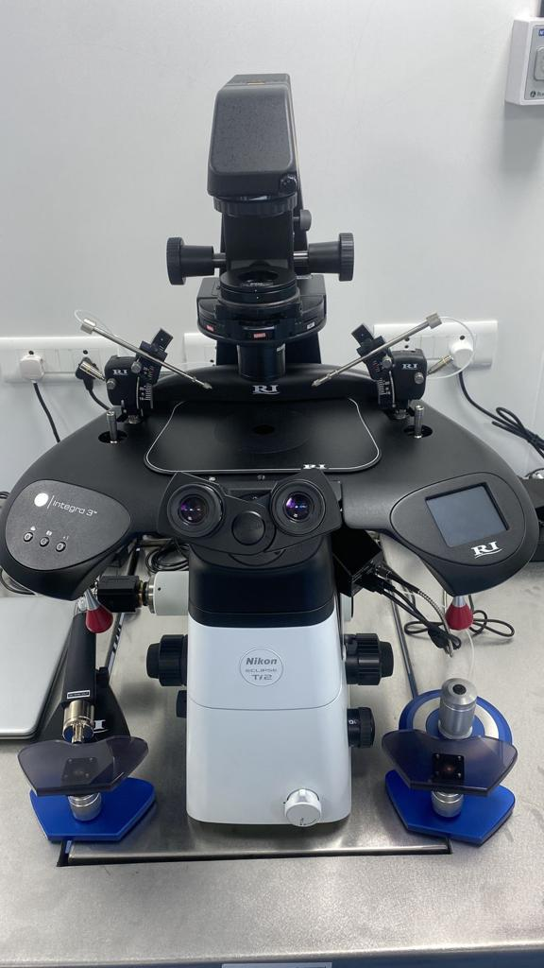

S.NO:12 IVF012 MICRO MANIPULATOR WITH INVERTED MICROSCOPE MAKE: NIKON NOS:01

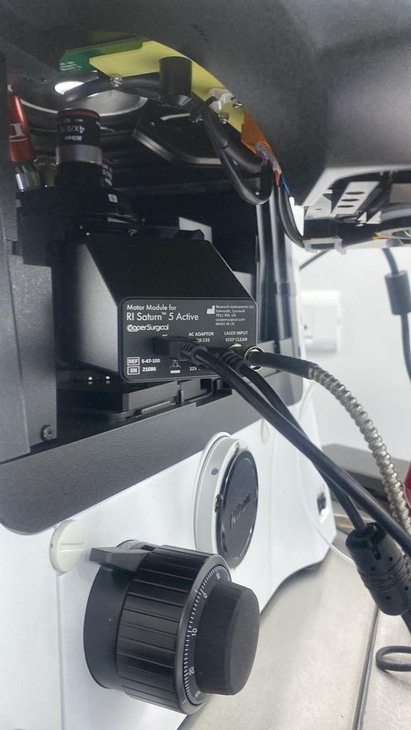

S.NO: 13 IVF013 IVF LASER SYSTEM

MAKE: NIKON NOS:01

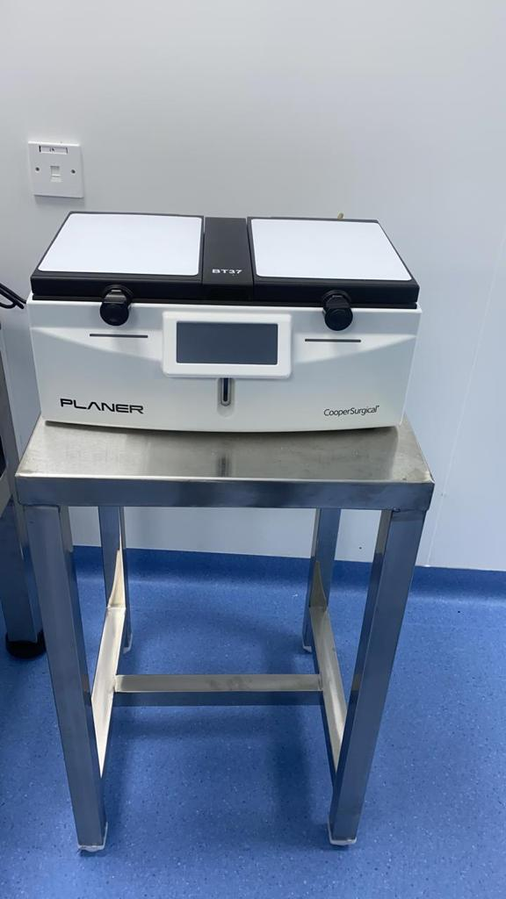

S.NO: 10 IVF010 TRIGAS BENCHTOP INCUBATOR MAKE: PLANER NOS:01

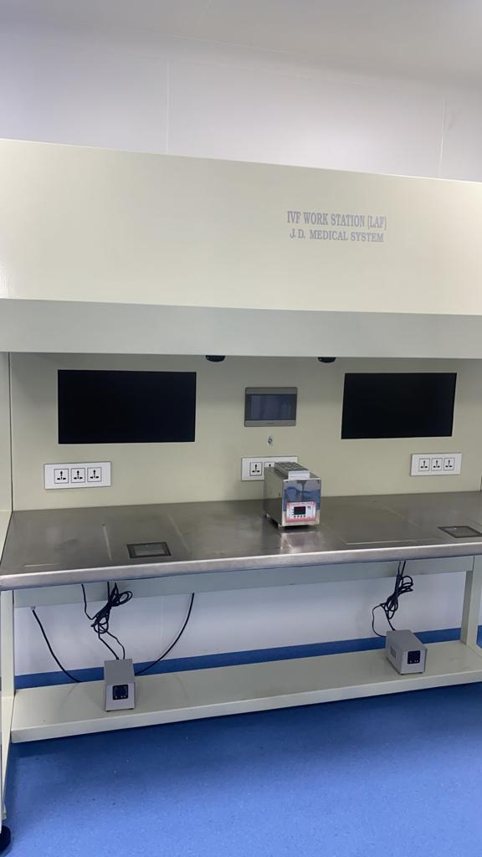

S.NO: 07 IVF007 IVF WORKSTATION WITH LAF MAKE: JD MEDICALS NOS:01

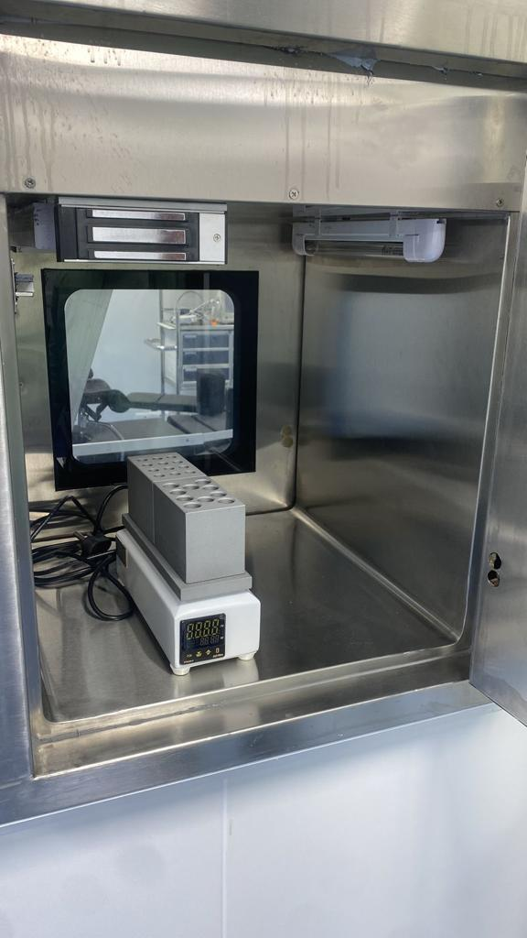

S.NO: 002 IVF002 IVF TEST TUBE WARMER

MAKE: JD MEDICALS NOS:03

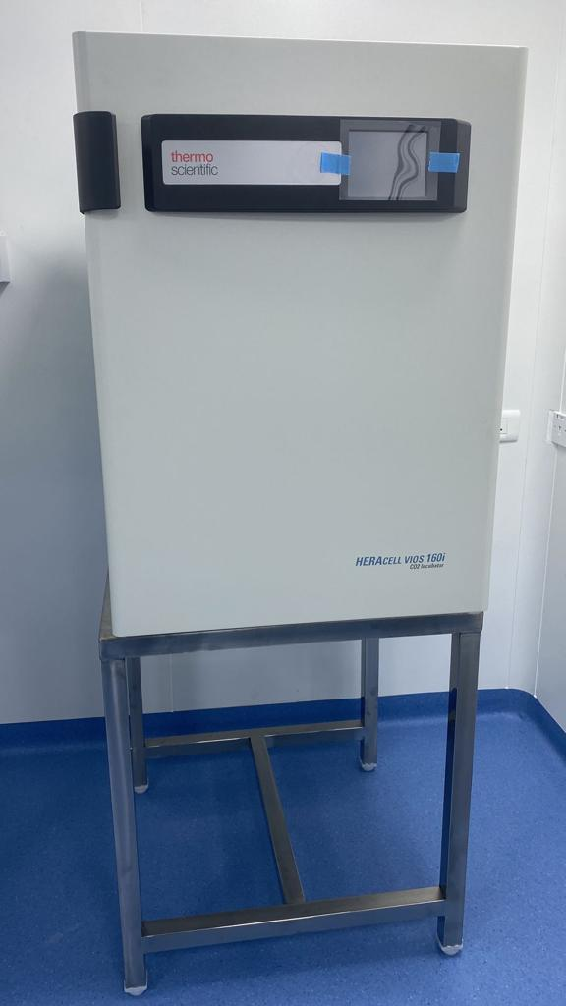S.NO: 009 IVF009 CO2 INCUBATORS

MAKE: THERMOFISHER NOS:02

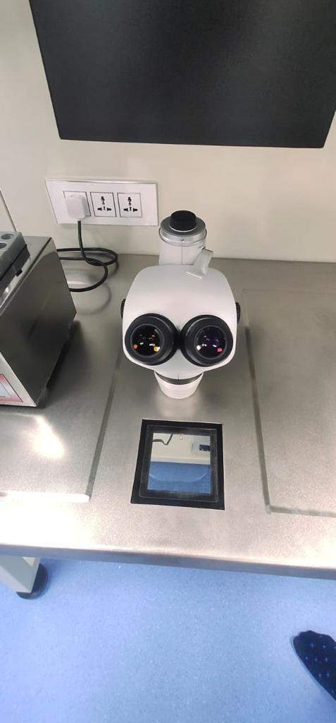

S.NO: 011 IVF011 TRINOCULAR STEREOZOOM MICROSCOPE MAKE: NIKON NOS:01

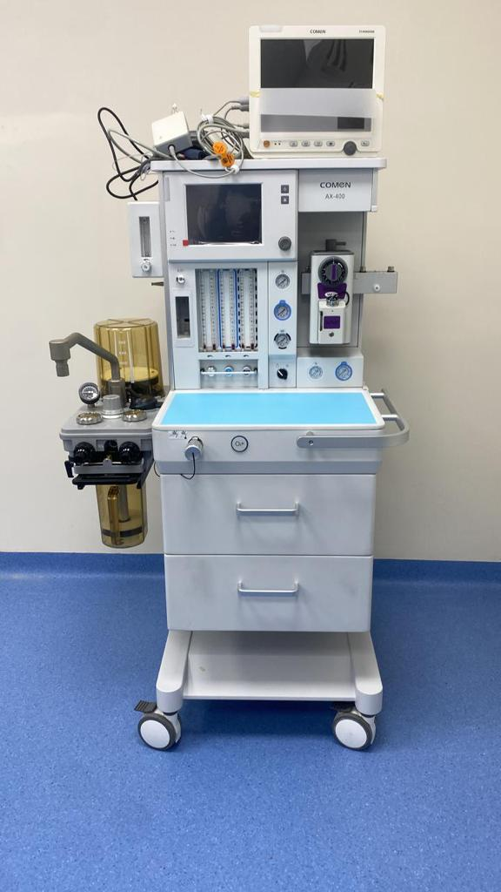S.NO: 030 IVF030 ANAESTHESIA WORKSTATION MAKE: COMEN NOS:01

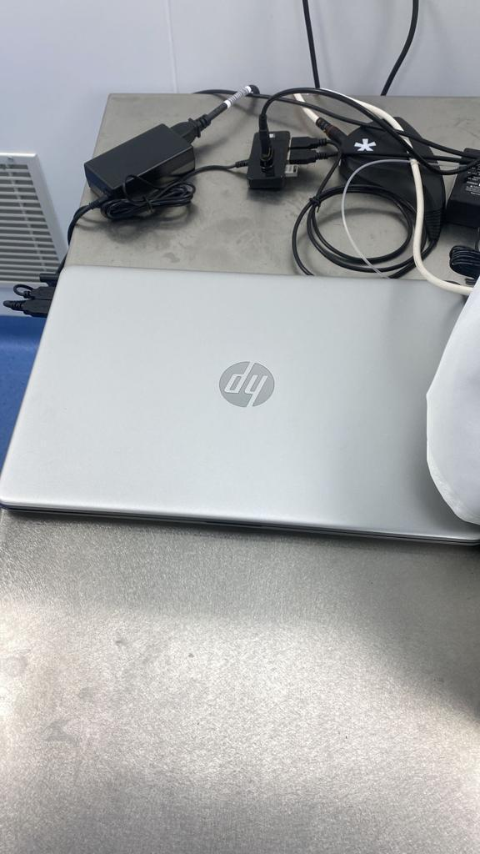S.NO: 037 IVF037 LAPTOP MAKE:HP NOS:02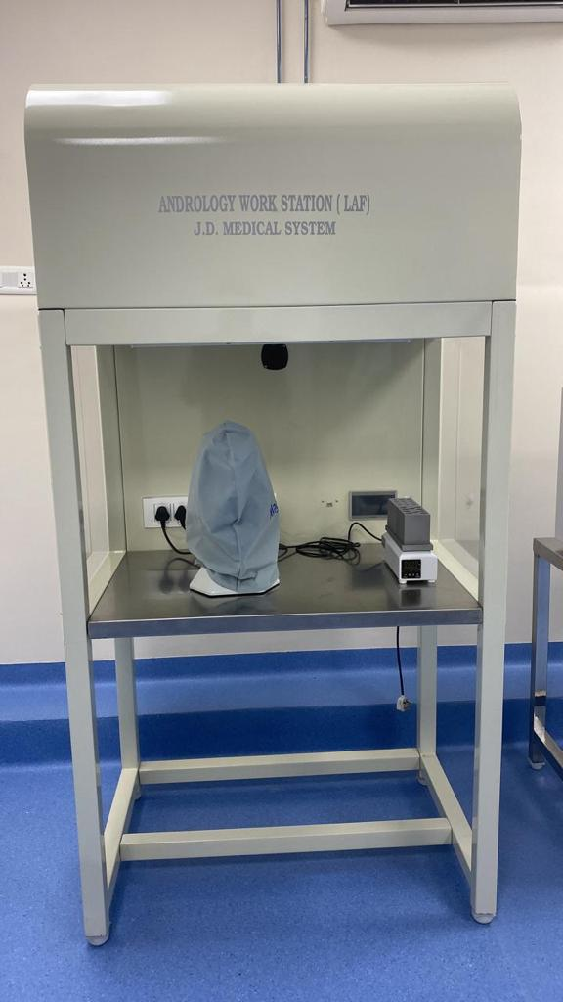S.NO: 021 IVF021 LAMINAR FLOW CABINET WITH ANDROLOGY WORKSTATION MAKE: JD MEDICALS

NOS:01

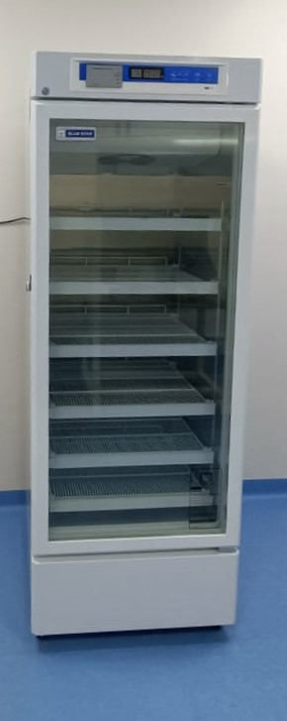

S.NO: 025 IVF025 PHARMACEUTICAL REFRIGERATOR MAKE: BLUESTAR NOS:01

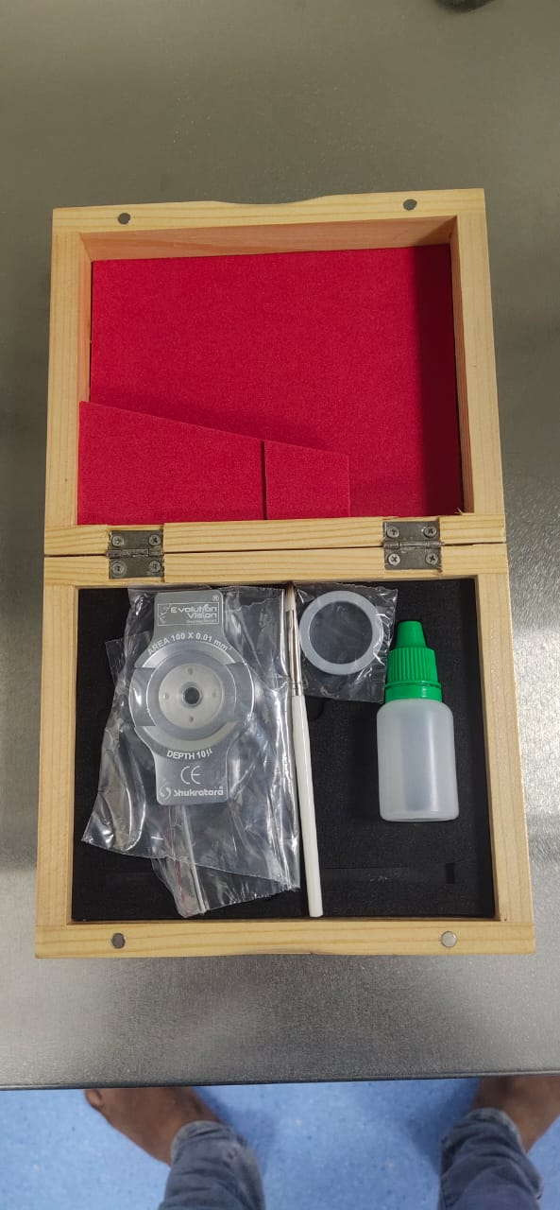

S.NO: 019 IVF019 SPERM COUNTING CHAMBER MAKE: SHUKRATAR NOS:01

S.NO: 020 IVF020 BINOCULAR MICROSCOPE MAKE: MAGNUS NOS:01

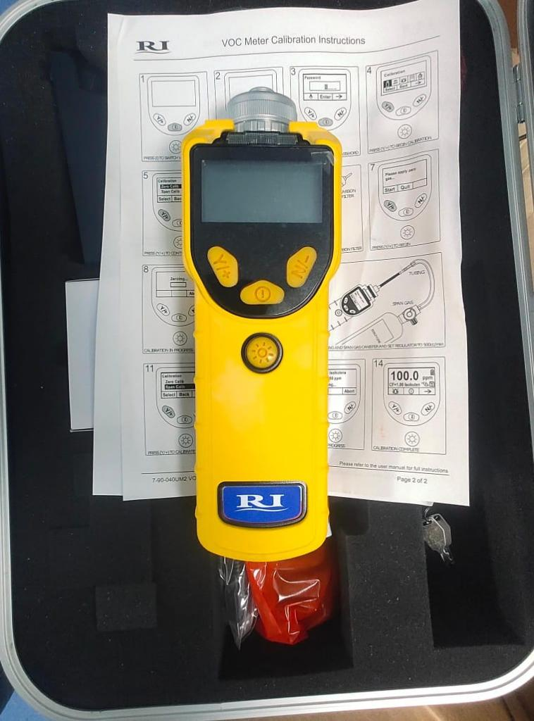

S.NO: 018 IVF018 VOC METER MAKE: RESEARCH INSTRUMENTS NOS: 01

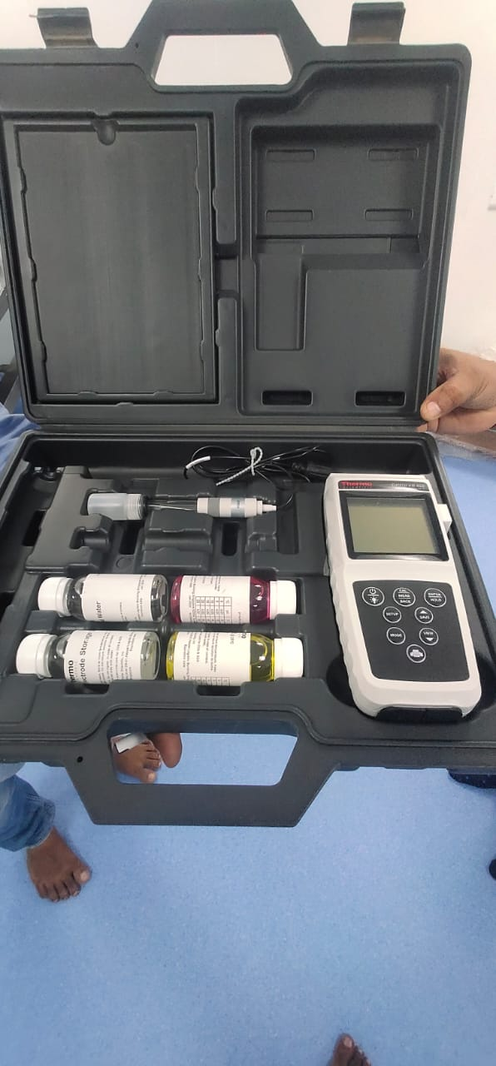

S.NO: 017/IVF017/PH METER/MAKE: THERMO SCIENTIFIC/NOS: 01

S.NO: 029 IVF029 SUCTION MACHINE

MAKE: YUWELL NOS:01

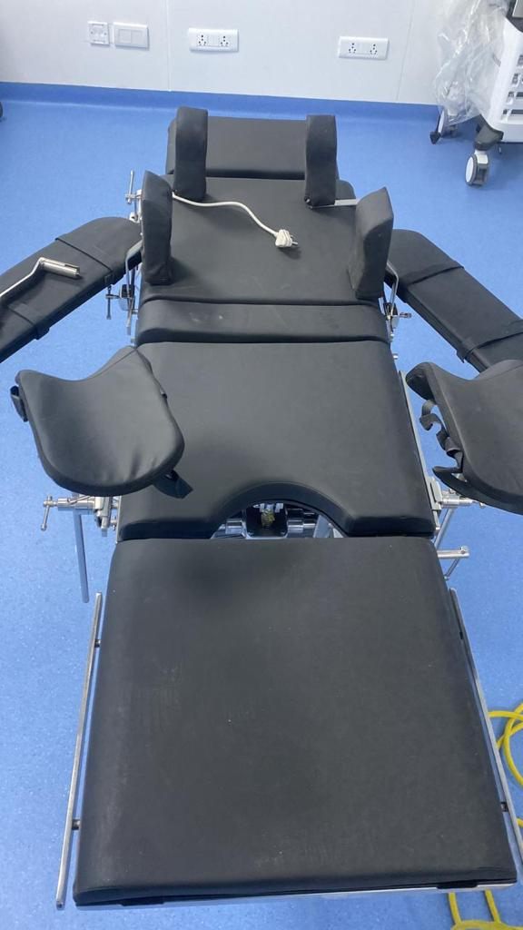S.NO: 004 IVF004 MOBILE OT TABLE MAKE: DESCO NOS:01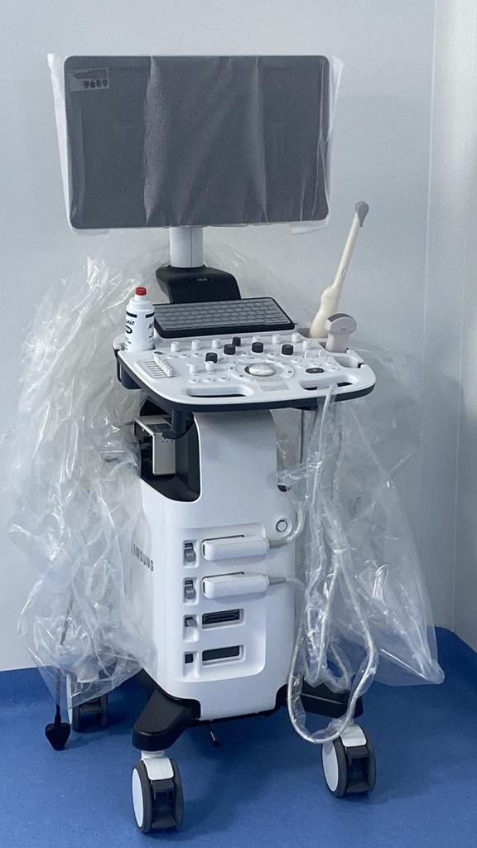S.NO: 003 IVF003 ULTRASOUND SCAN MACHINE MAKE: SAMSUNG NOS:02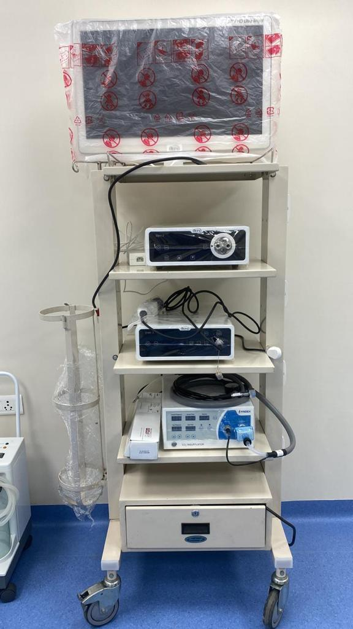S.NO: 032/IVF032/OPERATIVE HYSTEROSCOPY AND RESECTOSCOPE/ MAKE: AKINO/NOS:01

S.NO: 033/IVF032/OPERATIVE LAPAROSCOPY SET/MAKE: AKINO/NOS:01

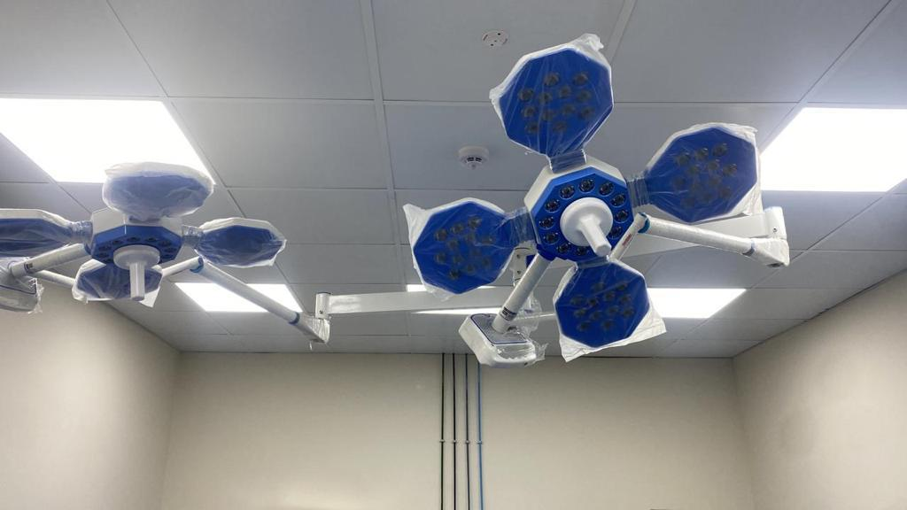S.NO: 005/IVF005/LED PROCEDURE LIGHTS DOUBLE DOME/MAKE: DESCO/ NOS:01

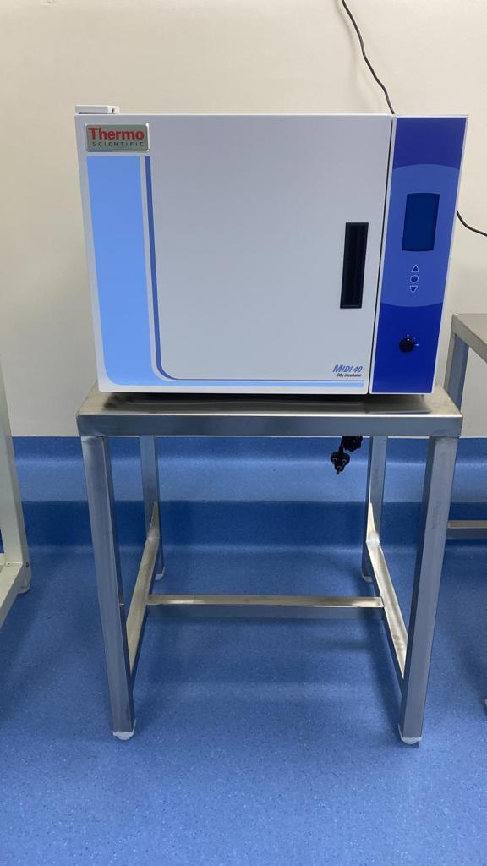S.NO:023 IVF023 DRY INCUBATOR MAKE: THERMOFISHER NOS:01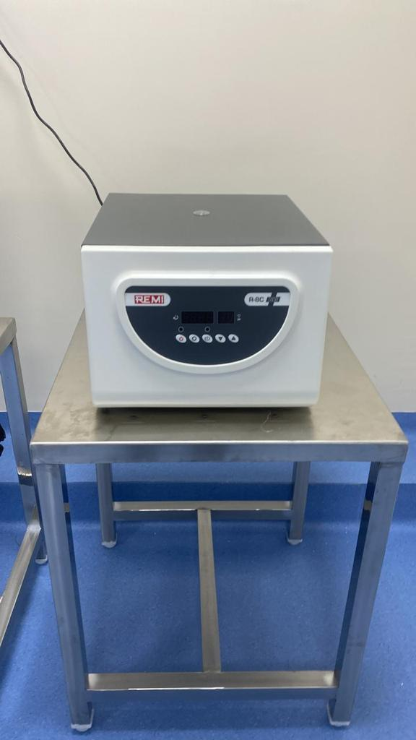S.NO: 022 IVF022 CLINICAL CENTRIFUGE MACHINE MAKE: REMI NOS:01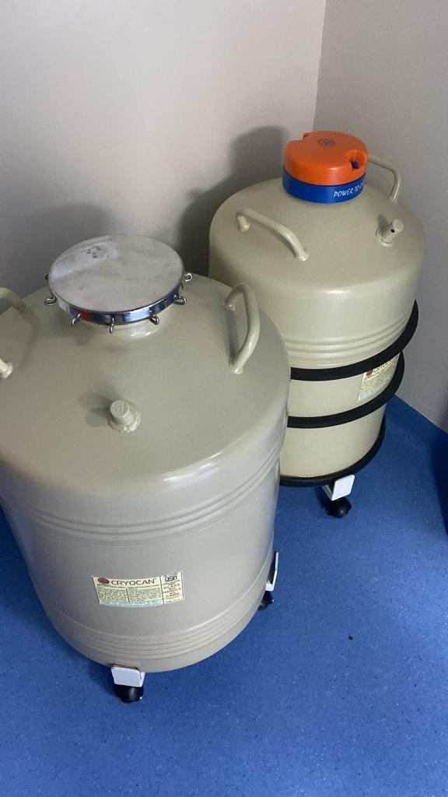S.NO: 026 IVF026 CRYOCANE TA 26 LTR WITH WHEELS MAKE: IBP NOS:02

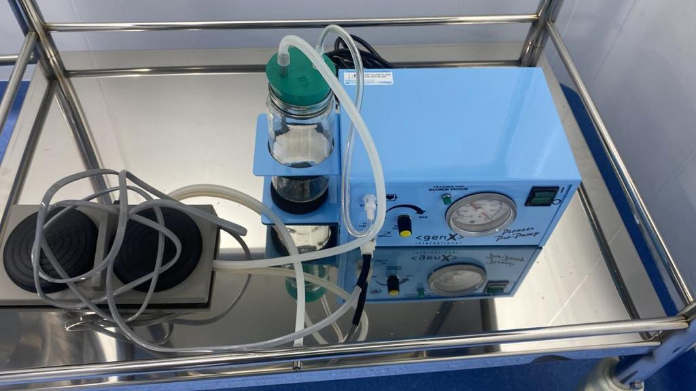

S.NO: 001 IVF001 OVUM ASPIRATION PUMP MAKE: PIONEER NOS:02

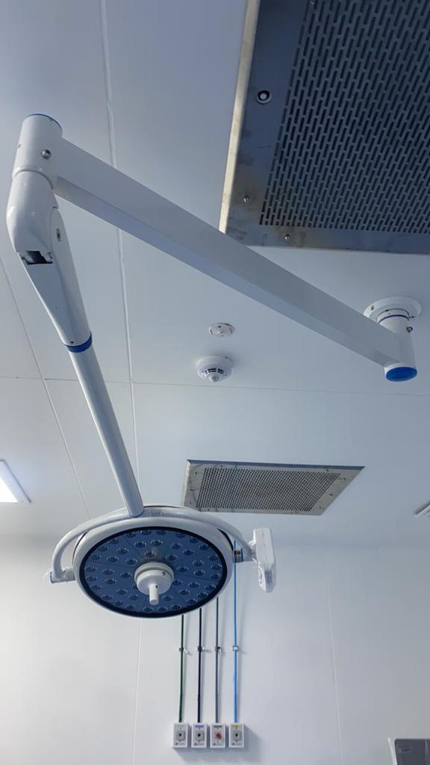S.NO: 006 IVF006 LED PROCEDURE LIGHT SINGLE DOME MAKE: DESCO NOS:01

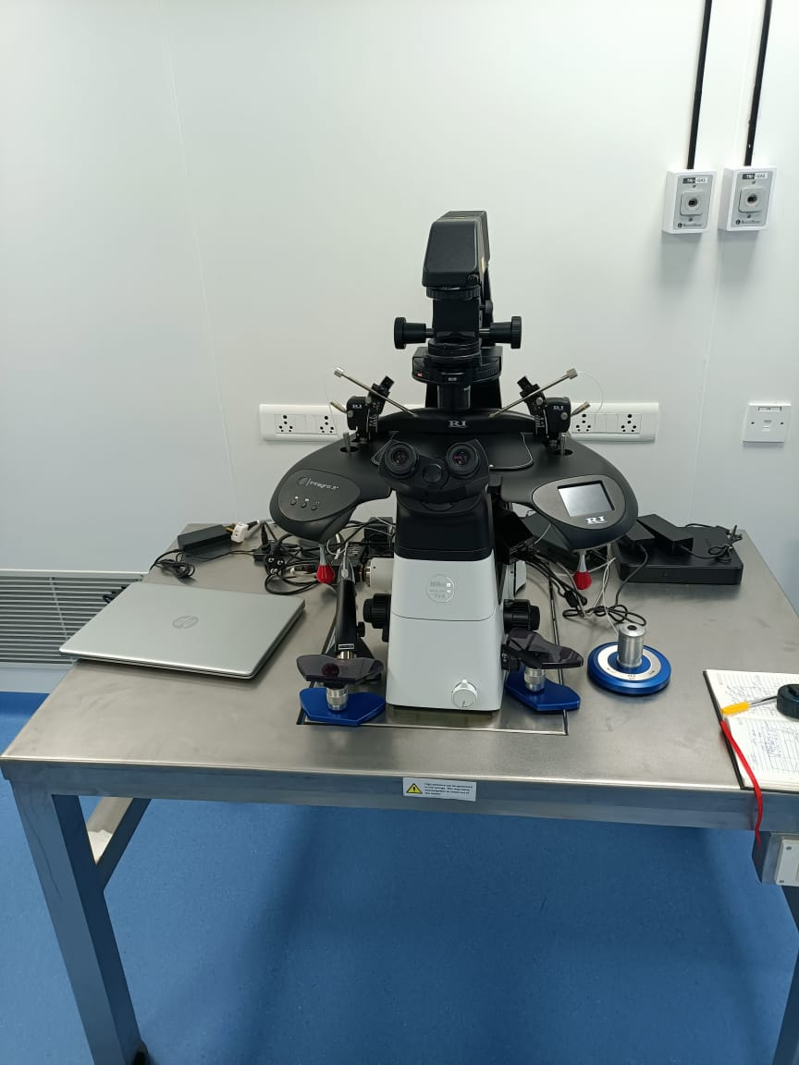S.NO: 008 IVF008 ANTIVIBRATION TABLE MAKE: JD MEDICALS NOS:01

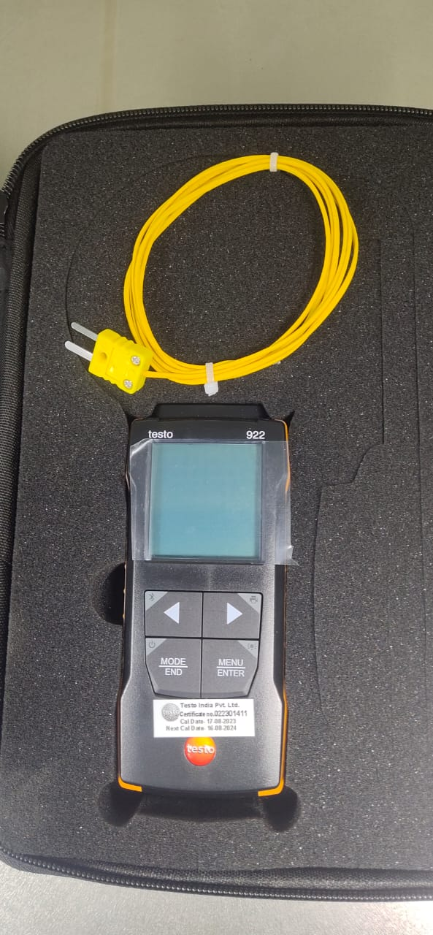

S.NO: 014/IVF014/IVF THERMOMETER WITH PROBE/MAKE:TESTO/NOS:01

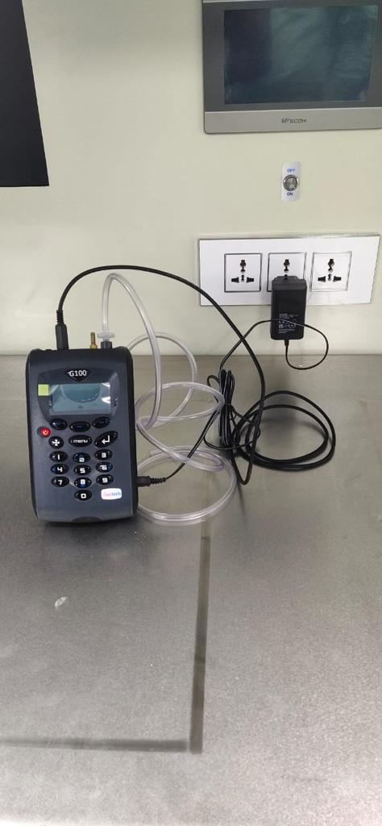

S.NO: 015/IVF015/CO2 & O2 ANALYZER/ MAKE: GEOTECH/NOS:01

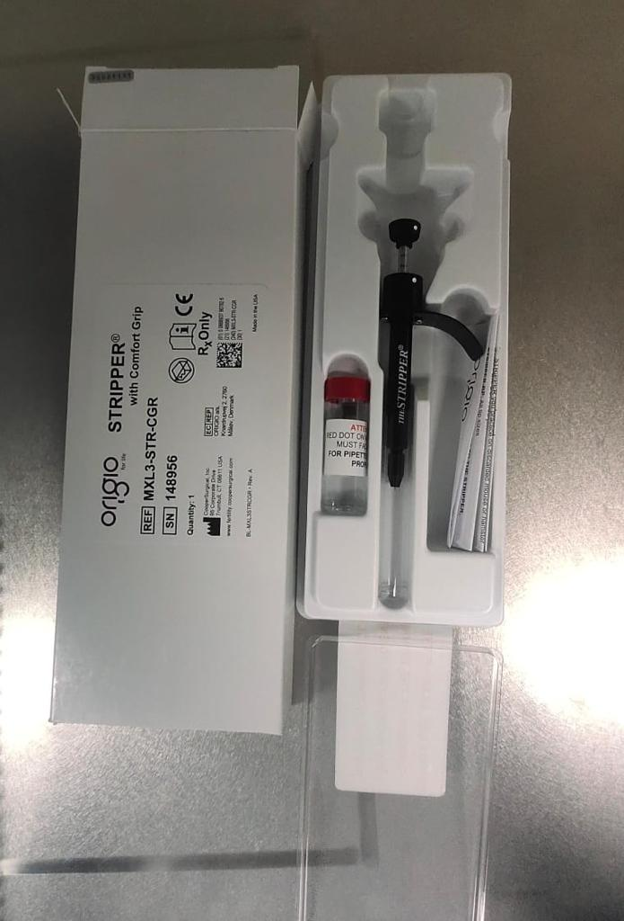

S.NO: 024/IVF024/PIPETTER & DENUDATION SYSTEM/MAKE: COOPER SURGICALS/NOS:01

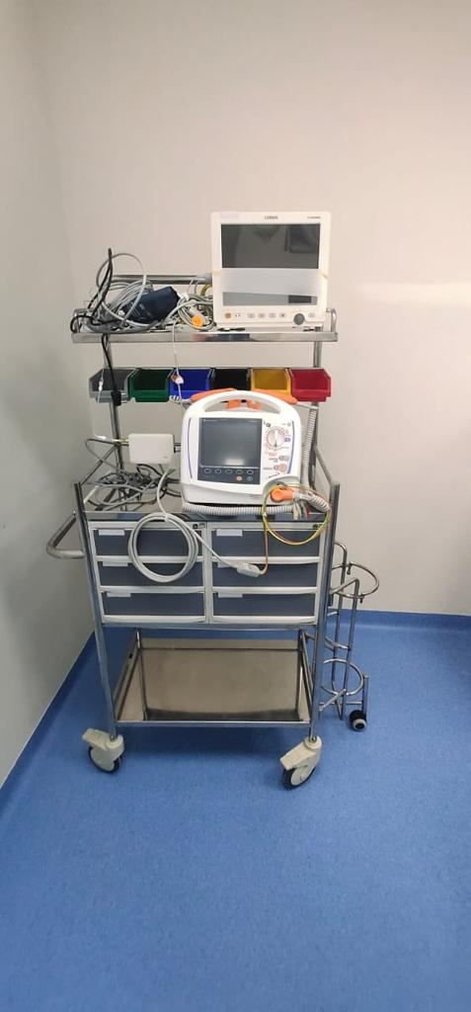

S.NO:028/IVF028/7 PARA PATIENT MONITOR/MAKE: COMEN/NOS:02

S.NO:027/IVF027/DEFIBRILLATOR/MAKE:NIHON KOHDEN/NOS:01

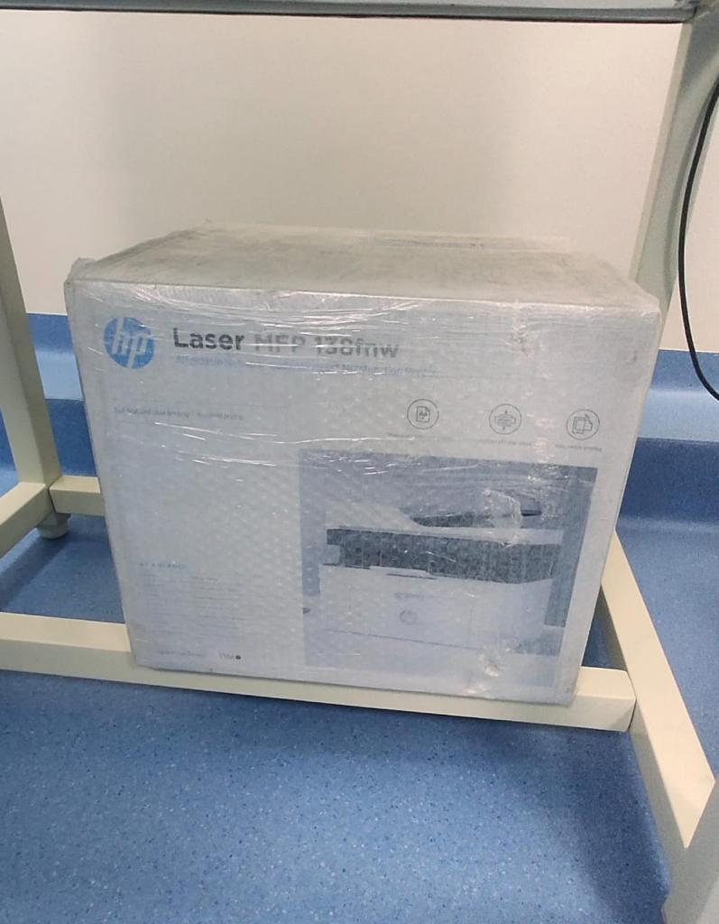

S.NO:034/IVF034/MUTLIFUNCTIONAL PRINTER/MAKE: HP/NOS:01